**Factory Design Pattern:**

It is mainly used for decoupling the client-side object creation from concrete class. This reduces the client work to change the code of object creation when there is a modification on the supporting code. Provides a common interface to use the application without bothering about of the changes in application. This is achieved by creating a static member function also called as factory method that handles the object creation mechanism depending on the client usage of application.

Most common usage of Factory Pattern:

1 Populating different views in android.

2 In GUI to have different views etc.

**Advantages:**

**1** Decoupling of Concrete classes only deals with interface.

2 Provides hooks which can be easily extended. SOLID -> OCP

**Disadvantages:**

1 When not properly used it becomes an anti-pattern.

2 Cluttering of different derived classes around the base class to avoid this use templatized classes.

Basic Model

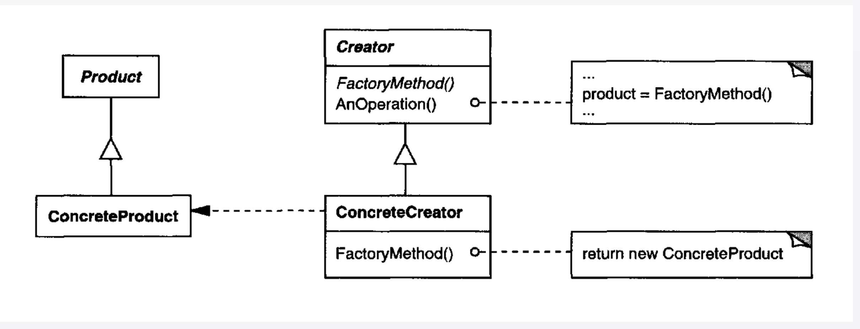

Example : Factory method by taking the electric bill management.